SIMATS ENGINEERING (SAVEETHA SCHOOL OF ENGINEERING)
Department of Computer Science and Engineering
CO2 ASSESSMENT TOOL 2 – Architecture Design Assignment
Course Code | CSA10 / CSA1063 | Course Title | Software Engineering
CO Assessed | CO2 | Assessment | Assessment Tool 2 – Architecture Design Assignment
Weightage | 20% | Total Marks | 25
CO2 Statement | Perform detailed requirements analysis, design scalable architectures, and prioritize features with a focus on cross-disciplinary skills
Student Name | Shaik Afra Aiman | Reg. No. | 1911260142
Date | 26-10-2026 | Duration | 60 minutes

Code of Conduct
I Shaik Afra Aiman / 1911260142 certify that this submission is my original work and that I have adhered to the guidelines specified for this assessment. I understand that any violation of academic integrity rules will result in disciplinary action.
Signature of the Student: Afra
Annexure A – Architecture Design Assignment
ARCHITECTURE DESIGN REPORT
Problem Statement 34: Intelligent Public Service Complaint Resolution Platform
The problem statement assigned to me is number 34, the Intelligent Public Service Complaint Resolution Platform. Public organizations such as municipal corporations, water boards and transport departments receive a large number of complaints every day about roads, drinking water, sanitation, street lights, transport and other civic services. In most offices these complaints are still sorted and forwarded by clerks. This takes time, the same complaint is sometimes sent to the wrong department, and nobody can easily say how long a department really takes to solve a problem.
The platform has to collect each complaint, classify it, decide how urgent it is, send it to the correct department, track it until it is resolved and keep the citizen informed at every step. It must also offer scalable APIs, role-based access, workflow automation, monitoring, analytics, testing and CI/CD, and the automatic classification must stay reviewable and transparent. In this report I analyse the requirements, select a suitable architectural style, draw the architecture, explain the components and their interactions, check the design against the six quality attributes and finally justify the decisions that were taken.
1. Analyze System Requirements
1.1 System Objectives
After studying the problem statement carefully, I have listed the main objectives of the system in Table 1. Each objective is later linked to a functional requirement and to an architectural decision, so that nothing in the design is there without a reason.
Table 1: System objectives
No. | Objective | What it means for the system
O1 | Collect and classify public complaints | Accept complaints from several channels in one common format and assign a category and sub-category automatically.
O2 | Prioritize issues by urgency and impact | Give every complaint a score so that a burst water pipe or an open manhole is handled before a minor request.
O3 | Route complaints to responsible departments | Map category and location to the correct department, zone and officer without manual forwarding.
O4 | Track status and service-level targets | Keep the full status history and run SLA timers with warnings and escalation.
O5 | Provide citizen notifications and dashboards | Send SMS, e-mail and app updates and give dashboards to citizens, officers and supervisors.
O6 | Implement secure APIs, testing, CI/CD and monitoring | Protect every API, test automatically, deploy through a pipeline and watch the system health.
O7 | Maintain transparency and audit trails | Record who or what changed a complaint, including the reason behind every automatic decision.

1.2 Stakeholders and Users
The architecture has to serve different kinds of users who use the system in very different ways. The stakeholders I identified are given in Table 2.
Table 2: Stakeholders of the platform
Stakeholder | Role in the system | Main needs
Citizen | Raises complaints and follows their progress | Simple submission, complaint ID, regular updates, option to give feedback or reopen
Call-centre operator | Registers complaints received by phone or SMS | Fast entry form, duplicate check, status lookup
Department officer | Resolves the assigned complaints | Clear work list, location details, easy status update
Department supervisor | Monitors the department and handles escalations | Overdue list, workload view, SLA reports
System administrator | Manages users, categories, rules and SLA values | Configuration without code change, monitoring access
Auditor / oversight authority | Checks fairness and performance of the service | Read-only audit logs, performance reports

1.3 Functional Requirements
The functional requirements that influence the architecture are listed in Table 3. They are written from the objectives above and from the typical working of a public grievance office.
Table 3: Functional requirements
ID | Requirement | Description
FR1 | Complaint submission | Citizens and operators submit a complaint through web, mobile app, SMS or call centre with description, location and optional photo.
FR2 | Registration | The system gives a unique complaint ID and checks for duplicate complaints from the same area.
FR3 | Automatic classification | The complaint is classified into a category (roads, water, sanitation, transport, utilities, other) and a sub-category with a confidence score.
FR4 | Human review | Low confidence or disputed classifications go to a review queue where an officer can confirm or correct them.
FR5 | Prioritization | A priority score is calculated from urgency, impact, location sensitivity and number of repeat complaints.
FR6 | Routing | The complaint is sent to the right department, zone and officer using routing rules and current workload.
FR7 | Workflow management | The complaint moves through defined states (Registered, Classified, Assigned, In Progress, On Hold, Resolved, Closed, Reopened).
FR8 | SLA tracking | Each complaint has a target time based on category and priority, with warnings and automatic escalation.
FR9 | Notifications | The citizen and the officer are informed on every important status change by SMS, e-mail or push message.
FR10 | Citizen tracking and feedback | Citizens can track a complaint by its ID, see their own complaints and give feedback after resolution.
FR11 | Operational dashboards | Officers and supervisors see pending, overdue and resolved complaints and department workload.
FR12 | Analytics and reports | Average resolution time, SLA compliance, category trends and hotspot areas are reported.
FR13 | Access control | Role-based access and management of users and departments.
FR14 | Audit trail | Every user action and every automatic decision is logged with time, user or model version, and reason.
FR15 | Integration APIs | Secure APIs let existing department systems and approved external systems exchange complaint data.
FR16 | Configuration | Administrators can change categories, routing rules, SLA values and priority weights without changing code.

1.4 Non-Functional Requirements
The non-functional requirements decide how well the system must work, and they have more influence on the choice of architecture than most functional requirements. The values given in Table 4 are my assumptions for a city-level deployment, because the problem statement does not give exact numbers.
Table 4: Non-functional requirements
ID | Category | Requirement | Target / measure
NFR1 | Performance | Fast response for citizens and officers | 95% of API calls under 500 ms; classification result within 5 seconds
NFR2 | Scalability | Handle sudden rise in complaints during floods, storms or water shortage | Normal load 50,000 complaints per day; peak up to 10 times normal
NFR3 | Availability | Service must be reachable almost always | 99.9% monthly uptime
NFR4 | Reliability | No complaint or status update may be lost | Zero data loss after acknowledgement; at-least-once event delivery
NFR5 | Security | Protect citizen data and restrict actions by role | HTTPS everywhere, JWT tokens, RBAC, encryption at rest, OWASP checks
NFR6 | Maintainability | Easy to change and test | Modules deployable independently; unit test coverage of at least 80%
NFR7 | Transparency | Automatic decisions can be explained and reviewed | Explanation and model version stored for every classification
NFR8 | Usability | Usable by all citizens | Web and mobile support, English, Tamil and Hindi, low-bandwidth pages
NFR9 | Interoperability | Work with existing systems | REST/JSON APIs with versioning; webhook support
NFR10 | Observability | Problems must be seen early | Central logs, metrics, tracing and alerts
NFR11 | Privacy | Personal data handled lawfully | Data minimization and retention rules in line with the Digital Personal Data Protection Act, 2023

1.5 Key Quality Attributes
From the above requirements, six quality attributes are the most important for this system. Table 5 explains why each one matters for a public complaint platform and how it affects the architecture.
Table 5: Quality attributes and their architectural influence
Quality attribute | Why it matters here | Influence on architecture
Scalability | Complaint volume is not constant. A flood can create thousands of complaints within hours. | Stateless services, horizontal scaling, message broker to absorb bursts
Maintainability | Rules, categories and departments change regularly, and the classification model will be retrained. | Small independent services, clear interfaces, automated tests and pipeline
Reliability | A lost complaint means a citizen is ignored, which damages trust in the system. | Persistent events, retries, idempotent handlers, database transactions
Availability | Emergencies may be reported at any hour of the day. | Redundant instances, multiple availability zones, health checks, failover
Performance | Citizens will not wait on slow pages, and officers need quick work lists. | Caching, search index, asynchronous processing of heavy tasks
Security | The system stores names, phone numbers and addresses, and officers can change complaint status. | API gateway, central identity service, RBAC, encryption, audit store

1.6 Assumptions and Constraints
- The platform is meant for one city or district administration with several departments, such as roads, water supply, sanitation, transport and electricity.
- Some departments already have their own software, so the platform must integrate with them through APIs and cannot replace them.
- Citizens may have low-bandwidth mobile connections, so the portal must be light and also support SMS.
- Cloud infrastructure with container support is available, and the development team is small, so tools must be standard and well documented.
1.7 Architecturally Significant Requirements
Not every requirement affects the architecture equally. After the analysis I found five requirements that really shape the structure of the system. First, the load is very uneven, so the system must scale up quickly and also absorb bursts. Second, the classification part (machine learning) changes at a different speed from the workflow part (business rules), so they should not be tied together in one deployable unit. Third, every automatic decision must be explainable, which needs a separate audit mechanism. Fourth, many departments with different systems must be connected, so integration has to be through clean APIs and events. Fifth, notifications and status changes must never be lost even if one part of the system is down.
2. Select a Suitable Software Architecture
2.1 Architectural Styles Considered
Before choosing, I compared the common architectural styles against the requirements. The comparison is given in Table 6.
Table 6: Comparison of candidate architectural styles
Style | Strengths for this problem | Weaknesses for this problem | Suitability
Layered (single application) | Simple to build and test; easy for a small team | Whole application scales as one unit; a change in one module needs full redeployment | Medium
Client-Server | Clear split between user interface and server | Describes only the outer structure, not how the server side is organized | Low
MVC | Good for the user interface and request handling | Is a pattern inside an application, not a system-level style | Low
Service-Oriented Architecture | Reuse of services; suits integration between departments | Heavy enterprise bus and shared data make it slow to change | Medium
Microservices | Independent deployment and scaling; each service owns its data | Higher operational complexity; needs good monitoring | High
Event-Driven | Absorbs bursts, decouples services, supports audit and analytics | Harder to trace and debug flows; eventual consistency | High
Serverless | No server management; pay per use | Cold starts, limits on long running tasks, provider dependency | Medium
Hybrid (Microservices + Event-Driven + Layered inside services) | Combines scalability, decoupling and clear internal structure | Needs discipline in design and good tooling | Very high

2.2 Selected Architecture
I have selected a hybrid architecture: event-driven microservices behind an API Gateway, where each microservice is internally built in layers. The outer structure is a set of small services such as Complaint Intake, Classification, Priority, Routing, Workflow and SLA, Notification, Analytics and Audit. The services talk to the outside world through one API Gateway and talk to each other mostly by publishing and consuming events through a message broker. Inside each service the code is arranged in the usual three layers, that is, the controller layer, the business logic layer and the data access layer. A central identity service takes care of login and roles, and a separate DevOps toolchain handles testing, deployment and monitoring.
2.3 Justification for the Selection
The reasons for this selection are listed below, and each of them is connected to the requirements analysed in Section 1.
- Uneven load (NFR2). In a microservice system only the busy services, for example Intake and Classification during a flood, need extra instances. The broker keeps the incoming events in a queue, so a sudden burst does not crash the downstream services.
- Different rates of change (FR3, FR16). The classification model and the routing rules change often, while the workflow states change rarely. Separate services let the team update the model without touching the workflow code.
- Reliability of notifications and status changes (NFR4). With an event-driven design an event is stored in the broker until every interested service has processed it, so a failed Notification service does not lose messages.
- Transparency and audit (FR14, NFR7). The Audit service is just another subscriber to the events. It can record everything without slowing down the business flow, and no service can skip the audit.
- Integration with departments (FR15, NFR9). The API Gateway gives one controlled entry point, and events can be exposed through webhooks, so legacy department systems can be connected without changing the core services.
- Security and role-based access (NFR5). The gateway and the identity service check every request in one place, which is easier to secure and review than checking in every module.
- Independent testing and CI/CD (O6, NFR6). Each service has its own repository, tests and pipeline, so a small change can be released quickly and safely.
- Fault isolation (NFR3). If the Analytics service fails, citizens can still submit complaints. In a single application the same failure could bring everything down.
2.4 Why the Other Styles Were Not Chosen
A plain layered monolith would be the easiest to build, and for a small town office it would be a fair choice. However, for a city platform whose load can rise ten times in a day, scaling the entire application for the sake of one busy module is wasteful, and every release would carry the risk of breaking an unrelated part. Classic SOA with an enterprise service bus was also considered, but it normally depends on a central bus and shared databases, which creates a bottleneck and makes the services difficult to change independently. A fully serverless design is attractive for cost, but the platform has long-running parts such as the workflow timers and the machine learning model, and the team would also become strongly dependent on a single cloud provider.
3. Draw the Software Architecture Diagram
Figure 1 shows the overall structure of the proposed platform. The diagram is drawn as a layered block diagram. Solid arrows show internal calls and dashed arrows show calls to external systems. Double-headed arrows mean that data flows in both directions, for example a request and its response.
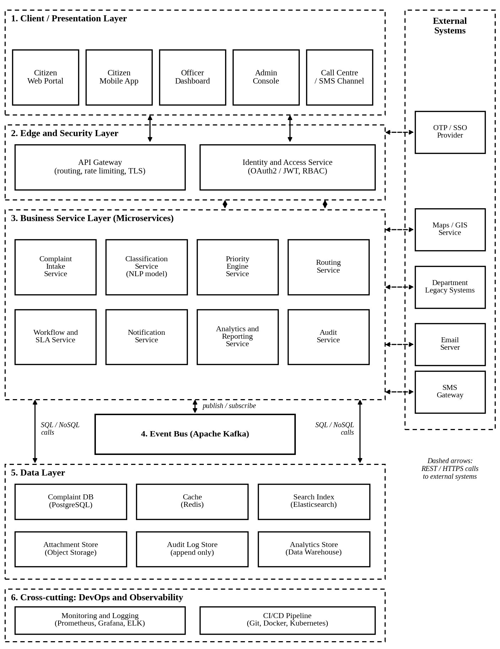
Figure 1: Overall software architecture of the Complaint Resolution Platform
The diagram contains six parts. The client layer holds all the channels used by citizens, officers and administrators. The edge layer contains the API Gateway and the Identity and Access Service. The business service layer holds the eight microservices. The event bus connects the services asynchronously. The data layer contains the databases, cache, search index, file storage and analytics store. The sixth block shows the cross-cutting DevOps and observability tools. The external systems, namely the OTP or single sign-on provider, the maps service, the department legacy systems, the e-mail server and the SMS gateway, are shown on the right side.
3.1 Notation Used
Table 7: Notation used in the diagrams
Symbol | Meaning
Solid rectangle | A component, service, database or external system
Dashed rectangle | A grouping such as a layer, a cluster or the set of external systems
Solid arrow | Synchronous call or the direction of flow between components
Dashed arrow | Call to or from an external system over HTTPS
Double-headed arrow | Two-way communication (request and response, or publish and subscribe)
Diamond | A decision point in a flowchart
Oval | Start or end of a flow

3.2 Internal Structure of a Microservice
Every microservice follows the same internal layered structure, which is shown in Figure 2 using the Routing Service as an example. The controller layer receives the REST calls and validates the input. The business logic layer contains the rules of the service. The data access layer talks only to the database owned by that service. The service also publishes and consumes events and exposes health and metrics endpoints so that the monitoring tools can check it.
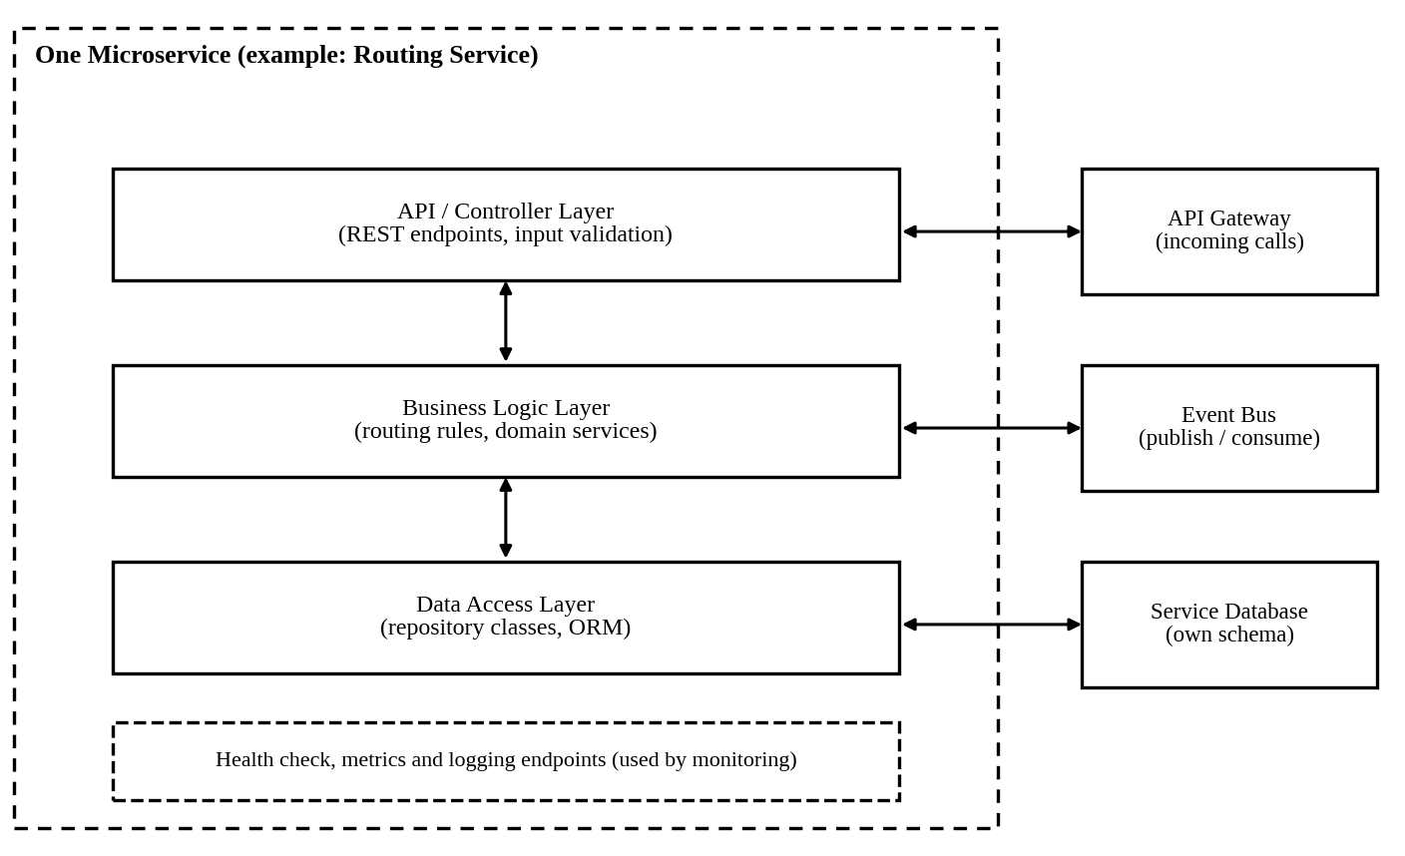
Figure 2: Internal layered structure of one microservice
3.3 Deployment View
Figure 3 shows how the same architecture is deployed. All services run as containers in a Kubernetes cluster spread over two availability zones. A load balancer with a web application firewall receives the traffic, and the database has a primary copy and a standby copy in different zones. The CI/CD pipeline pushes tested images to a container registry, from where they are deployed into the cluster, and the monitoring tools collect metrics from every node.
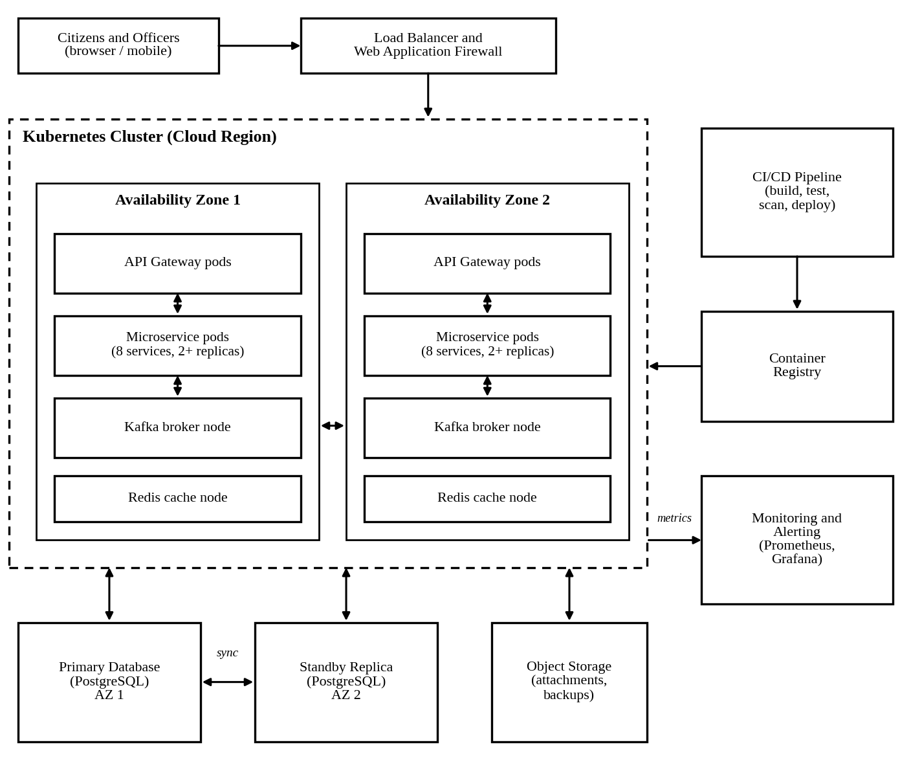
Figure 3: Deployment view of the platform
4. Explain Components and Their Interactions
4.1 Purpose and Responsibilities of the Components
Table 8 describes the components of the client and edge layers, and Table 9 describes the business services. The technologies mentioned are suggestions, and they can be replaced as long as the interfaces stay the same.
Table 8: Client, edge and infrastructure components
Component | Purpose | Main responsibilities
Citizen Web Portal and Mobile App | Main channel for citizens | Complaint form, photo and location upload, status tracking, feedback, language selection
Officer Dashboard | Work area for officers and supervisors | Assigned complaints, review queue, status update, overdue list, department reports
Admin Console | Configuration for administrators | Manage users, roles, categories, routing rules, SLA values and priority weights
Call Centre / SMS Channel | Entry for citizens who do not use the internet | Operator entry form and SMS parsing, both calling the same intake API
API Gateway | Single entry point to the backend | Routing of requests, rate limiting, TLS termination, token check, API versioning, request logging
Identity and Access Service | Authentication and authorization | Login with OTP or password, JWT issue and refresh, role and permission checks
Event Bus (Kafka) | Asynchronous communication | Stores and delivers events to the subscribed services, keeps order within a topic, allows replay
Monitoring and Logging | Observability | Collect metrics and logs, show dashboards, raise alerts on errors or slow responses
CI/CD Pipeline | Automation of build and release | Build, test, scan, create images and deploy to staging and production

Table 9: Business microservices
Service | Purpose | Responsibilities | Data owned
Complaint Intake | Receive and register complaints | Validate input, store attachments, generate ID, detect duplicates, publish complaint.registered | Complaint records, attachment links
Classification | Classify complaints automatically | Run the NLP model, return category, sub-category, confidence and explanation, send low-confidence cases to review | Model results, explanations, review feedback
Priority Engine | Decide how urgent a complaint is | Calculate priority score from urgency, impact, location sensitivity and repeats | Priority scores, weight settings
Routing | Choose the responsible department and officer | Apply routing rules by category and zone, consider workload, handle reassignment | Department directory, rules, assignments
Workflow and SLA | Control the life cycle of a complaint | Maintain states and allowed transitions, run SLA timers, raise warnings and escalations | Status history, SLA timers
Notification | Inform citizens and officers | Build messages from templates, send SMS, e-mail and push, retry on failure | Templates, delivery logs
Analytics and Reporting | Measure performance | Build dashboards for resolution time, SLA compliance, trends and hotspots | Aggregated data in the warehouse
Audit | Keep the audit trail | Record every event and user action in an append-only store, support search by complaint or user | Audit log

4.2 Working of the Key Services
Classification Service. This is the service that makes the platform intelligent. It reads the complaint text, which may be in English, Tamil or Hindi, and predicts the category and sub-category using a trained text classification model. It also returns a confidence value and the main words that influenced the decision. If the confidence is above a threshold set by the administrator, for example 0.80, the complaint moves forward automatically. Otherwise it is placed in the review queue, where an officer confirms or corrects the category. The correction is stored and used later for retraining. This design satisfies the requirement that the automatic classification stays reviewable and transparent. Figure 4 shows the classification pipeline.
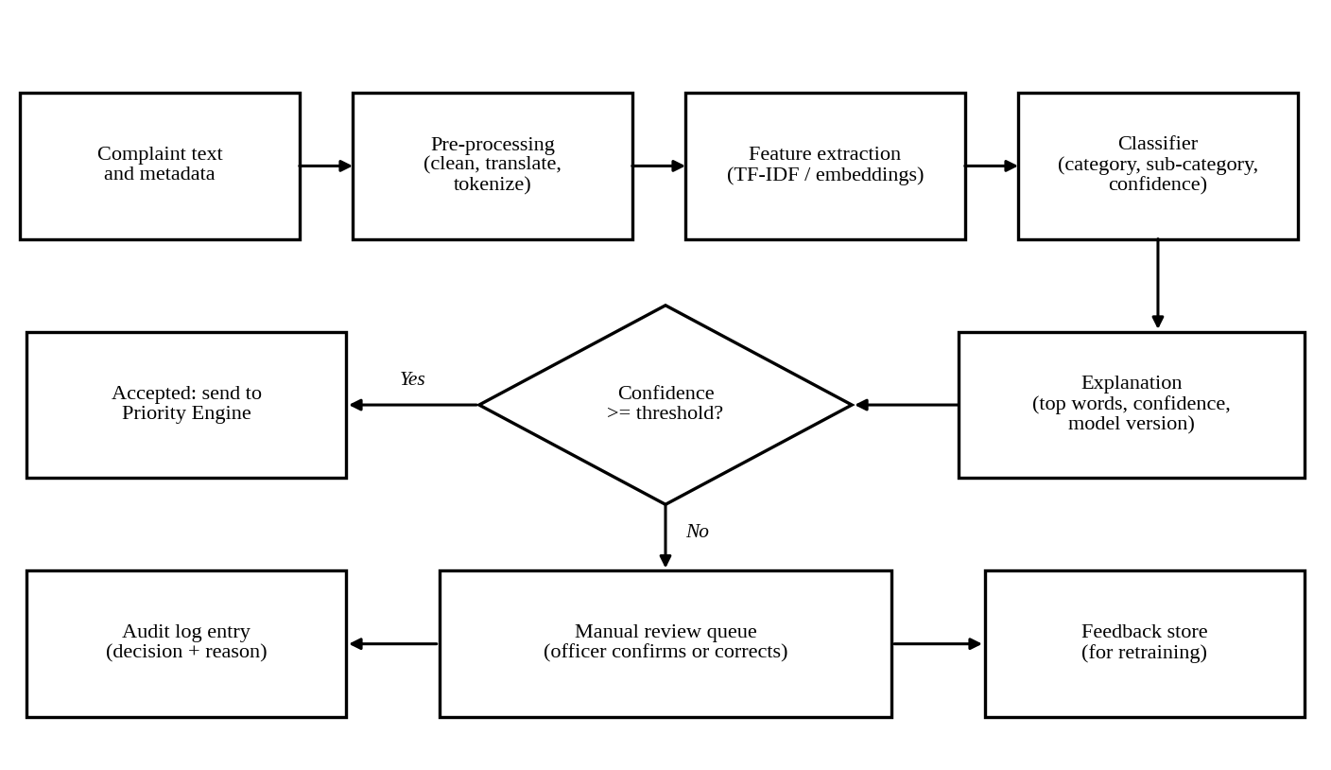
Figure 4: Classification pipeline with human review
Priority Engine. The priority score is calculated using four factors, each scored from 0 to 100. The weights are kept in the database so that the administrator can change them. The factors, their weights and the method of scoring are given in Table 10.
Table 10: Priority scoring factors
Factor | Weight | How it is scored
Urgency | 0.35 | Based on the sub-category, for example a burst pipe, a fallen electric pole or an open manhole scores high, while a faded road marking scores low
Impact | 0.30 | Estimated number of people affected, taken from the area type and the number of similar complaints nearby
Location sensitivity | 0.20 | Higher when the place is near a hospital, school, main road or relief camp
Repeat count | 0.15 | Higher when the same issue was reported before and is still open

Priority Score = (0.35 x Urgency) + (0.30 x Impact) + (0.20 x Location) + (0.15 x Repeat). As an example, a pipe burst near a hospital with urgency 95, impact 85, location 100 and repeat 40 gives 33.25 + 25.5 + 20 + 6 = 84.75, which falls in the Critical band. The bands and the SLA target that the Workflow service attaches to each band are given in Table 11.
Table 11: Priority bands and SLA targets
Priority band | Score range | Resolution target (SLA) | Escalation
Critical | 80 to 100 | 4 hours | Supervisor at 2 hours, department head at 4 hours
High | 60 to 79 | 24 hours | Supervisor at 18 hours
Medium | 40 to 59 | 72 hours | Supervisor at 60 hours
Low | 0 to 39 | 7 days | Supervisor at 6 days

Routing Service. Routing first looks up a rule table in which the category, sub-category and city zone point to a department. Then it selects an officer of that department, normally the one with the smallest number of open complaints. Because the rules are data and not code, the administrator can add a new department or a new zone from the Admin Console. If no rule matches, the complaint goes to a default control room queue so that it is never stuck.
Workflow and SLA Service. This service owns the status of every complaint. It allows only valid transitions, for instance a complaint cannot go from Registered to Closed without passing through Assigned and Resolved. When a complaint is assigned, it starts an SLA timer. If the time is close to the limit, it publishes an sla.warning event, and if the limit passes, it publishes sla.breached, which causes an escalation to the supervisor.
Notification Service. It listens to the events and sends the right message to the right person. Messages are built from templates in the language chosen by the citizen. If the SMS gateway does not respond, the message is retried with an increasing delay and the failure is logged, so that a short outage of the gateway does not stop the rest of the platform.
4.3 Communication Between Components
The platform uses two communication styles. Synchronous REST over HTTPS is used where the user needs an immediate answer, such as submitting a complaint, reading its status or logging in. Asynchronous events through the broker are used for the processing that happens after the complaint is accepted, such as classification, scoring, routing and notification. This means that the citizen gets the complaint ID within a second, and the heavier work continues in the background. Table 12 lists the main events.
Table 12: Main events exchanged through the event bus
Event | Published by | Consumed by | Purpose
complaint.registered | Intake | Classification, Audit, Analytics | New complaint is stored and ready for classification
complaint.classified | Classification | Priority Engine, Audit | Category and confidence are available
complaint.review.required | Classification | Workflow, Notification | Low confidence, officer review needed
complaint.prioritized | Priority Engine | Routing, Audit | Priority score and band are ready
complaint.routed | Routing | Workflow, Notification, Analytics | Department and officer are assigned
complaint.status.changed | Workflow | Notification, Analytics, Audit | Any change of status
sla.warning / sla.breached | Workflow | Notification, Routing, Analytics | Time limit near or crossed, start escalation
complaint.resolved / reopened | Workflow | Notification, Analytics, Audit | Closure and feedback or reopening by the citizen

The messages are exchanged in JSON format. Every event carries the complaint ID, a time stamp, an event ID and the version of the schema. The consuming services store the event ID of what they have processed, so that if the broker delivers the same event twice, which is possible with at-least-once delivery, the second copy is ignored. This property is called idempotency, and it is the reason why no complaint is processed twice.
4.4 Data Exchanged
The main data object that travels through the system is the complaint record. Table 13 shows its important fields and which service is responsible for each group of fields.
Table 13: Important fields of the complaint record
Field group | Fields | Set by
Identification | complaint_id, channel, created_at, citizen_id (or phone) | Intake
Content | description, language, location (latitude, longitude, ward), attachments | Intake
Classification | category, sub_category, confidence, explanation, model_version, reviewed_by | Classification
Priority | priority_score, priority_band, factor_values | Priority Engine
Assignment | department_id, zone, officer_id, assigned_at | Routing
Progress | status, status_history, sla_due_at, sla_state, resolved_at | Workflow and SLA
Feedback | rating, comment, reopened_flag | Intake / Workflow

4.5 Overall Workflow of the System
The complete life cycle of a complaint is shown in Figure 5, and the steps are explained below the figure.
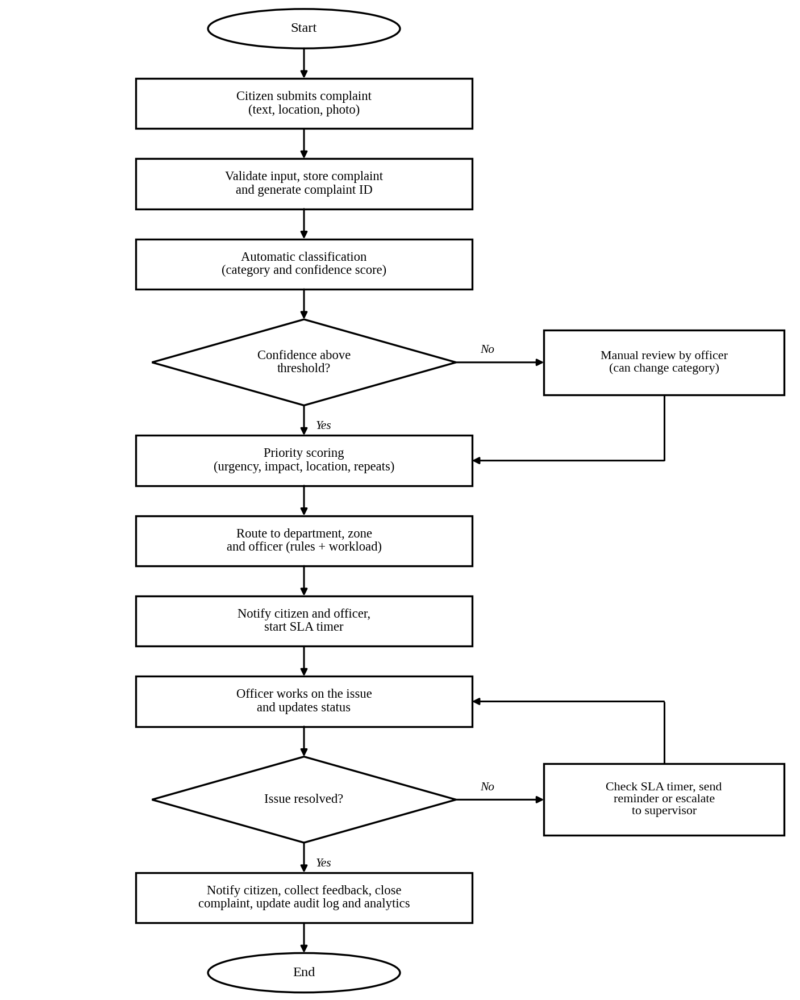
Figure 5: Workflow of a complaint from submission to closure
- The citizen submits the complaint through the web portal, the app, SMS or the call centre. The request reaches the API Gateway, which checks the token and forwards it to the Intake service.
- Intake validates the data, stores the complaint and the attachments, generates the complaint ID and returns it to the citizen. It then publishes complaint.registered.
- The Classification service picks the event, classifies the complaint and publishes the result. If the confidence is low, the complaint goes to the manual review queue and continues after the officer confirms the category.
- The Priority Engine calculates the score and band, and the Routing service chooses the department and officer.
- The Workflow service sets the status to Assigned and starts the SLA timer. The Notification service sends the first update to the citizen and a new task alert to the officer.
- The officer works on the issue and updates the status. Each update produces a status event that triggers a notification and an audit entry.
- If the issue is not resolved in time, the SLA check sends a reminder and later escalates it to the supervisor.
- After resolution the citizen is notified and can give feedback or reopen the complaint. A reopened complaint returns to the Assigned state with a higher repeat count.
- The Audit and Analytics services record every step, so that the dashboards and reports always show the current picture.
4.6 Role-Based Access
Access to the functions is controlled by roles. The Identity service issues a token that contains the user's role, and each service checks the permission before doing the work. Table 14 shows the permissions given to each role.
Table 14: Role and permission matrix
Permission | Citizen | Operator | Officer | Supervisor | Admin | Auditor
Submit complaint | Yes | Yes | No | No | No | No
View own complaints | Yes | Yes | Yes | Yes | Yes | No
View department complaints | No | No | Yes | Yes | Yes | Yes
Update status | No | No | Yes | Yes | No | No
Override classification | No | No | Yes | Yes | No | No
Reassign or escalate | No | No | No | Yes | Yes | No
Configure rules, SLA, weights | No | No | No | No | Yes | No
View analytics | No | No | Limited | Yes | Yes | Yes
View audit logs | No | No | No | Limited | Yes | Yes

4.7 Data Stores
Each service owns its data and no other service reads its tables directly. The data technologies are selected according to the type of data and are listed in Table 15.
Table 15: Data stores and their use
Data store | Technology | Used for | Reason
Complaint database | PostgreSQL | Complaints, assignments, status history, rules | Transactions and relationships between records
Cache | Redis | Sessions, rule tables, frequently read statuses | Very fast reads, reduces database load
Search index | Elasticsearch | Search by ID, text, area and date | Fast full-text and filter search
Attachment store | Object storage | Photos and documents | Cheap, large and durable file storage
Audit log store | Append-only table or log store | Audit records | Cannot be edited, supports transparency
Analytics store | Data warehouse | Aggregated data for reports | Keeps heavy reports away from the live database

5. Discuss Quality Attributes
This section evaluates how the proposed architecture addresses the six quality attributes. A short summary is given in Table 17 at the end of the section.
5.1 Scalability
Every microservice is stateless, because the session information is kept in the token or in the Redis cache and not in the memory of the service. Because of this, new instances can be added or removed at any time. Kubernetes autoscaling increases the number of pods when CPU use or the length of the broker queue crosses a limit, for example when Intake and Classification are overloaded during a flood. The broker works as a buffer, and if the Classification service is slower than the Intake service for some minutes, the events wait in the topic and are processed later without being lost. The topics are divided into partitions, so that several consumers can process events in parallel. The database scaling is handled by read replicas for reports and by the search index for heavy queries.
5.2 Security
Security is built into several layers. All traffic uses HTTPS, and the web application firewall at the entrance filters common attacks. The API Gateway rejects requests that have no valid token and limits the number of requests from one client to avoid abuse. The Identity service uses OTP or password login with short-lived JWT access tokens, and the permissions follow the roles given in Table 14. Personal data such as phone numbers and addresses is encrypted at rest and masked in the dashboards where it is not needed. Inside the cluster the services communicate only through approved paths, and secrets such as database passwords are stored in a secrets manager and not in the code. Input validation and parameterized queries protect against injection attacks, and the pipeline runs dependency and static security scans before every release. The Audit service gives accountability, since every access to a sensitive record and every change of a complaint is recorded.
5.3 Performance
The citizen-facing calls are kept short by moving heavy work to the background. When a complaint is submitted, the Intake service only validates and stores it and then returns the ID, while classification, scoring and routing are done after that through events. Frequently read data, such as the rule tables and complaint status, is cached in Redis. The search index handles text search and filters, so the main database is not loaded with such queries. Analytics queries run on the warehouse, which is separate from the live system, so that a big report cannot slow down the officers. The performance targets of NFR1 are checked by load tests in the pipeline, and the monitoring dashboards show the response time of every service.
5.4 Reliability
Reliability is mainly about making sure that no complaint is lost and that the status shown is correct. The Intake service writes the complaint to the database before it sends the acknowledgement. Events are stored on disk in the broker with replication, and consumers confirm an event only after processing it. If a service crashes in between, the event is delivered again, and the idempotent handling prevents duplicate work. Failed calls to external systems, such as the SMS gateway, are retried with a delay, and after a fixed number of failures the message is moved to a dead-letter queue, from where it can be inspected and sent again. Circuit breakers stop a service from waiting for a failing dependency for too long.
5.5 Maintainability
The platform is divided according to business responsibilities, so a developer who needs to change the SLA rules works in the Workflow service and does not need to understand the Classification service. All services follow the same internal layered structure (Figure 2) and the same coding and API standards, which makes it easy for a new team member to move between them. The APIs are versioned, so a service can be changed without breaking its consumers. Configuration such as routing rules and SLA values is stored as data, so most business changes do not need a code release at all. Testing and delivery are automated in the CI/CD pipeline shown in Figure 6, and the testing levels are listed in Table 16.
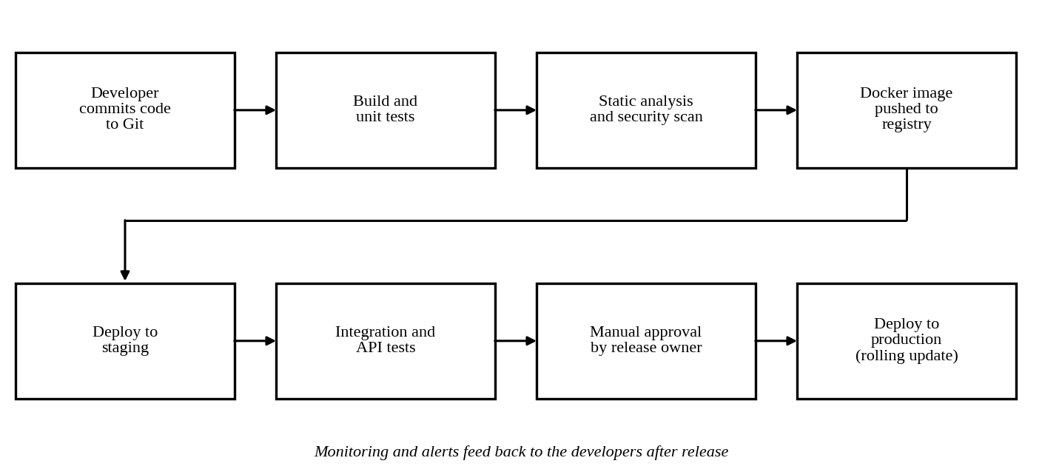
Figure 6: CI/CD pipeline of the platform
Table 16: Testing levels in the pipeline
Level | What is tested | When it runs
Unit tests | Business rules such as priority score and state transitions | Every commit
Static analysis and security scan | Code quality, known vulnerable libraries, hard-coded secrets | Every commit
Contract and API tests | Request and response formats between services and with the gateway | Every merge
Integration tests | A complaint passing through the events from intake to routing in staging | Before each release
Load and performance tests | Behaviour at ten times the normal load | Before major releases
Model evaluation tests | Accuracy of the classifier on a held-out set of complaints | Whenever the model is retrained

5.6 Availability
To reach the target of 99.9% uptime the platform removes single points of failure. Every service runs with at least two replicas, placed in two availability zones, and the load balancer sends traffic only to healthy instances, which are identified by the health check endpoints. The database has a standby replica with automatic failover, and the broker and the cache also run on more than one node. Deployments use the rolling update method, so a new version is started step by step and the old version is removed only after the new one is healthy. Because of the loose coupling of the services, the failure of a non-critical service, such as Analytics, does not stop complaint registration. The platform also keeps a simple degraded mode: if the classification service is down, new complaints are still registered and are placed in a pending queue for later classification or manual handling.
5.7 Summary of Quality Attributes
Table 17: How the architecture addresses each quality attribute
Attribute | Main tactics used | How it is measured
Scalability | Stateless services, autoscaling, partitioned broker topics, read replicas | Complaints per second handled; time to scale out under load
Security | Gateway, JWT, RBAC, encryption, secrets manager, audit store, security scans | Failed attack tests, scan results, access audit review
Performance | Asynchronous processing, Redis cache, search index, separate warehouse | 95th percentile response time under 500 ms
Reliability | Durable events, retries, idempotent consumers, dead-letter queue, backups | Number of lost complaints (target zero), failed message rate
Maintainability | Small services, layered code, versioned APIs, configuration as data, CI/CD | Test coverage, time needed for a change, build success rate
Availability | Replicas in two zones, health checks, failover, rolling updates, degraded mode | Monthly uptime of at least 99.9%

6. Justify Architectural Decisions
6.1 Rationale Behind the Main Decisions
The important decisions taken while designing the platform are recorded in Table 18 together with the alternatives that were considered and the reason for the final choice.
Table 18: Architectural decision log
No. | Decision | Alternatives considered | Reason for the choice
D1 | Event-driven microservices | Layered monolith, SOA, serverless | Meets uneven load, independent change and fault isolation
D2 | Single API Gateway | Direct calls from clients to each service | One place for security, rate limiting and versioning
D3 | Database per service | One shared database | Loose coupling; each service can change its schema freely
D4 | Kafka as event bus | Simple queue, direct REST calls | Durable, replayable events and high throughput
D5 | Central identity service with JWT and RBAC | Login logic in each service | Consistent security and easier audit
D6 | Rules stored as data for routing, SLA and priority | Rules written in code | Administrators can change them without a release
D7 | NLP classifier with confidence threshold and human review | Fully automatic or fully manual classification | Saves effort while keeping decisions reviewable and transparent
D8 | Containers on Kubernetes | Virtual machines per service | Easy scaling, self-healing and uniform deployment
D9 | Append-only audit store fed by events | Logging inside each service | Tamper resistance and one complete trail
D10 | Automated CI/CD with staged deployment | Manual testing and deployment | Fast, repeatable and safer releases

6.2 Trade-offs Considered
No architecture is perfect, and the chosen one also has costs. Table 19 shows the main trade-offs and how I plan to reduce their effect.
Table 19: Trade-offs of the selected architecture
Benefit gained | Cost accepted | How the cost is reduced
Independent scaling and deployment of services | More services to deploy, monitor and secure | Containers, a common service template and central monitoring
Loose coupling through events | Eventual consistency; flows are harder to trace | Correlation ID in every event, distributed tracing, workflow service as the source of truth for status
Durable and replayable events | Running a message broker needs skill | Use a managed broker service and keep the topic design simple
Own database for each service | Reports across services are more difficult | Analytics store built from events
Machine learning classification | Some wrong classifications are unavoidable | Confidence threshold, human review and regular retraining with corrected data
High availability with replicas in two zones | Higher infrastructure cost | Autoscaling and scaling down in quiet hours

The simpler monolith would have lower cost and lower complexity at the start, and I considered it seriously because the project team is small. I still rejected it, since the main requirements of this problem are scalability, transparency and integration with many departments, and these are the places where a monolith becomes difficult after the system grows.
6.3 Support for Future Enhancements
The architecture is open to extension because a new feature can usually be added as a new service that subscribes to the existing events, without changing the existing services. Some enhancements that can be added in this way are:
- A chatbot or voice channel in regional languages for filing complaints, which calls the same Intake API.
- Image-based classification, in which the photo of a pothole or an overflowing drain is analysed by an additional model service.
- Predictive analytics that identifies areas where complaints are likely to repeat, based on the data in the analytics store.
- Integration with smart city sensors, such as water level or street light monitors, which can raise complaints automatically.
- A public open data API and a transparency dashboard showing the performance of every department.
6.4 System Integration
Integration with other systems is supported in two ways. First, the API Gateway publishes documented and versioned REST APIs for department systems that want to read or update complaints. Second, selected events can be delivered to external systems as webhooks, so that a department system can react immediately when a complaint is routed to it.
6.5 Long-term Maintainability
Long-term maintainability is supported by the small size of the services, the shared standards, the automated tests and the use of configuration data in place of code. Because every service has a clear owner and a clear interface, individual services can be rewritten or replaced, for example a better classification model or a different notification provider, without a large project. The decision log (Table 18) and the API documentation are kept with the code, so the reasons behind the design are available to the people who maintain it later.
6.6 Risks and Mitigation
Table 20: Main risks and their mitigation
Risk | Effect | Mitigation
Wrong automatic classification | Complaint goes to a wrong department and is delayed | Confidence threshold, review queue, easy reassignment, monthly model evaluation
Broker or service failure | Delay in processing | Replicated broker, retries, dead-letter queue, health checks, alerts
Leak of personal data | Loss of citizen trust and legal problems | Encryption, RBAC, masking, audit logs, security scans, data retention rules
Very high load during disasters | Slow response | Autoscaling, queue buffering, load testing before the rainy season
Legacy department systems not ready | Delay in integration | Adapter components, manual fallback queue for the department
Team inexperience with microservices | Poor quality or slow delivery | Service template, training, code review, simple technology choices

6.7 Conclusion
For the Intelligent Public Service Complaint Resolution Platform I selected an event-driven microservices architecture with an API Gateway, where every service is built in layers. This hybrid design handles the uneven complaint load, keeps the classification and workflow parts independent, makes every automatic decision visible through the audit trail and the review queue, and is easy to connect with the existing departments. The six quality attributes, namely scalability, security, performance, reliability, maintainability and availability, are addressed by specific tactics, and the trade-offs of the design have been identified along with ways to reduce them.
References
- L. Bass, P. Clements and R. Kazman, Software Architecture in Practice, 4th ed., Addison-Wesley, 2021.
- S. Newman, Building Microservices, 2nd ed., O'Reilly Media, 2021.
- I. Sommerville, Software Engineering, 10th ed., Pearson, 2016.

Rubrics for Calculation
Evaluation Criteria | Excellent (4 Marks) | Good (3 Marks) | Satisfactory (2 Marks) | Needs Improvement (1 Mark)
System Requirement Analysis (30%) | Thoroughly analyzes the problem statement, accurately identifies functional and non-functional requirements, and clearly explains quality attributes influencing the architecture. | Analyzes most requirements with minor omissions or limited explanation. | Identifies only basic requirements with partial analysis. | Requirement analysis is incomplete, inaccurate, or lacks clarity.
Selection of Software Architecture (25%) | Selects the most appropriate architectural style with strong technical justification aligned to system requirements. | Selects a suitable architecture with reasonable justification. | Architecture is partially suitable with limited justification. | Inappropriate architecture selected or justification is missing.
Architecture Diagram and Component Design (20%) | Produces a clear, complete, and well-structured architecture diagram with all major components, interfaces, and interactions accurately represented. | Diagram is mostly complete with minor omissions or notation issues. | Diagram includes only essential components and lacks sufficient detail. | Diagram is incomplete, unclear, or technically incorrect.
Component Interaction and Quality Attribute Analysis (15%) | Clearly explains component responsibilities, interactions, and thoroughly discusses scalability, security, performance, reliability, maintainability, and availability. | Explains most components and quality attributes with minor gaps. | Provides limited explanation of interactions and addresses only some quality attributes. | Component interactions and quality attributes are poorly explained or missing.
Architectural Justification and Technical Presentation (10%) | Provides strong justification for architectural decisions, discusses trade-offs and future enhancements, and presents a well-organized, professional report. | Provides adequate justification with minor gaps; report is well organized. | Limited justification with minimal discussion of trade-offs or future scope; report needs improvement. | Justification is weak or absent; report lacks organization and technical clarity.

Criteria | Mark
System Requirement Analysis (30%) | /5
Selection of Software Architecture (25%) | /5
Architecture Diagram and Component Design (20%) | /5
Component Interaction and Quality Attribute Analysis (15%) | /5
Architectural Justification and Technical Presentation (10%) | /5
TOTAL | /25

